*I ♥ Lamp*

Design and fabricate a functional lamp using flat-pack design concepts with 3D design tools. It should include:

* + An artist’s statement describing the lamp

This lamp is inspired by the cabin that we built in our basement. Each room of our basement floor has a different theme and the one when you come down the stairs is made to resemble a cabin. It invites guests in because of the homey and nature rich feel it has. Currently there are two French doors outside the screened in porch area to give it some natural light while still being in a basement. The space is currently decorated with some fish and deer mounts to add to the lodge/cabin feel. Thus, the design of this lamp is to expand upon this homey feel. Inspired by a lantern that could be found in an old cabin home, this lamp allows the guest to further be entranced by this homey feel. It adds more soft, but minimal light exactly how it would be found in a real cabin home.

* + Multi-point perspective renderings
    - Isometric

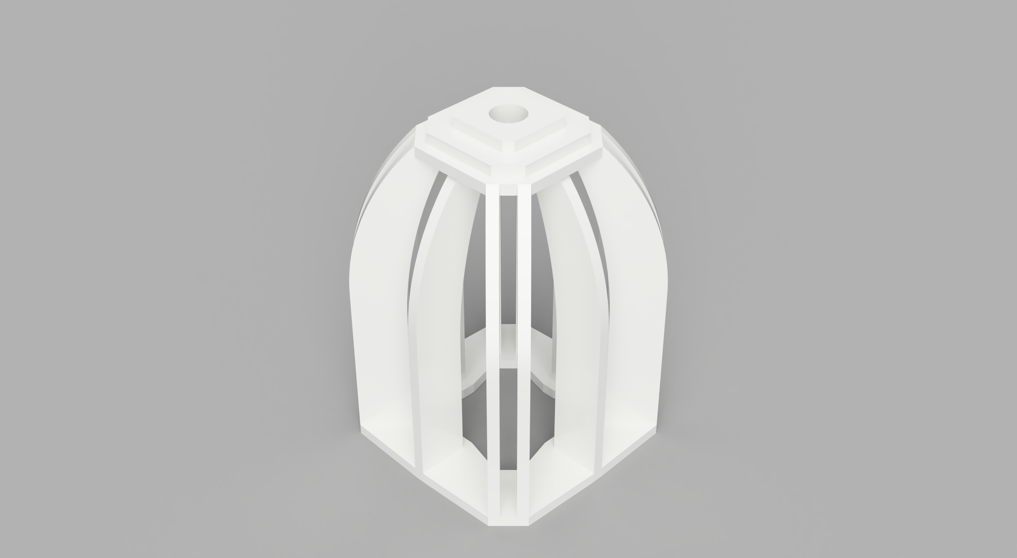

* + - Top

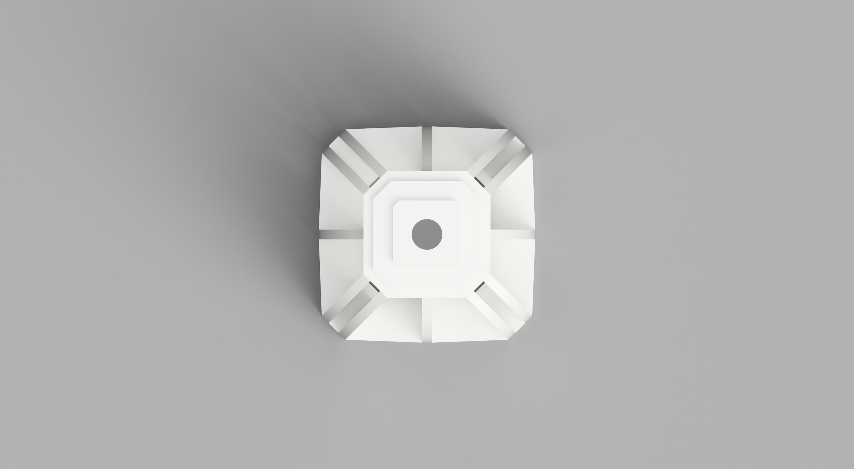

* + - Side

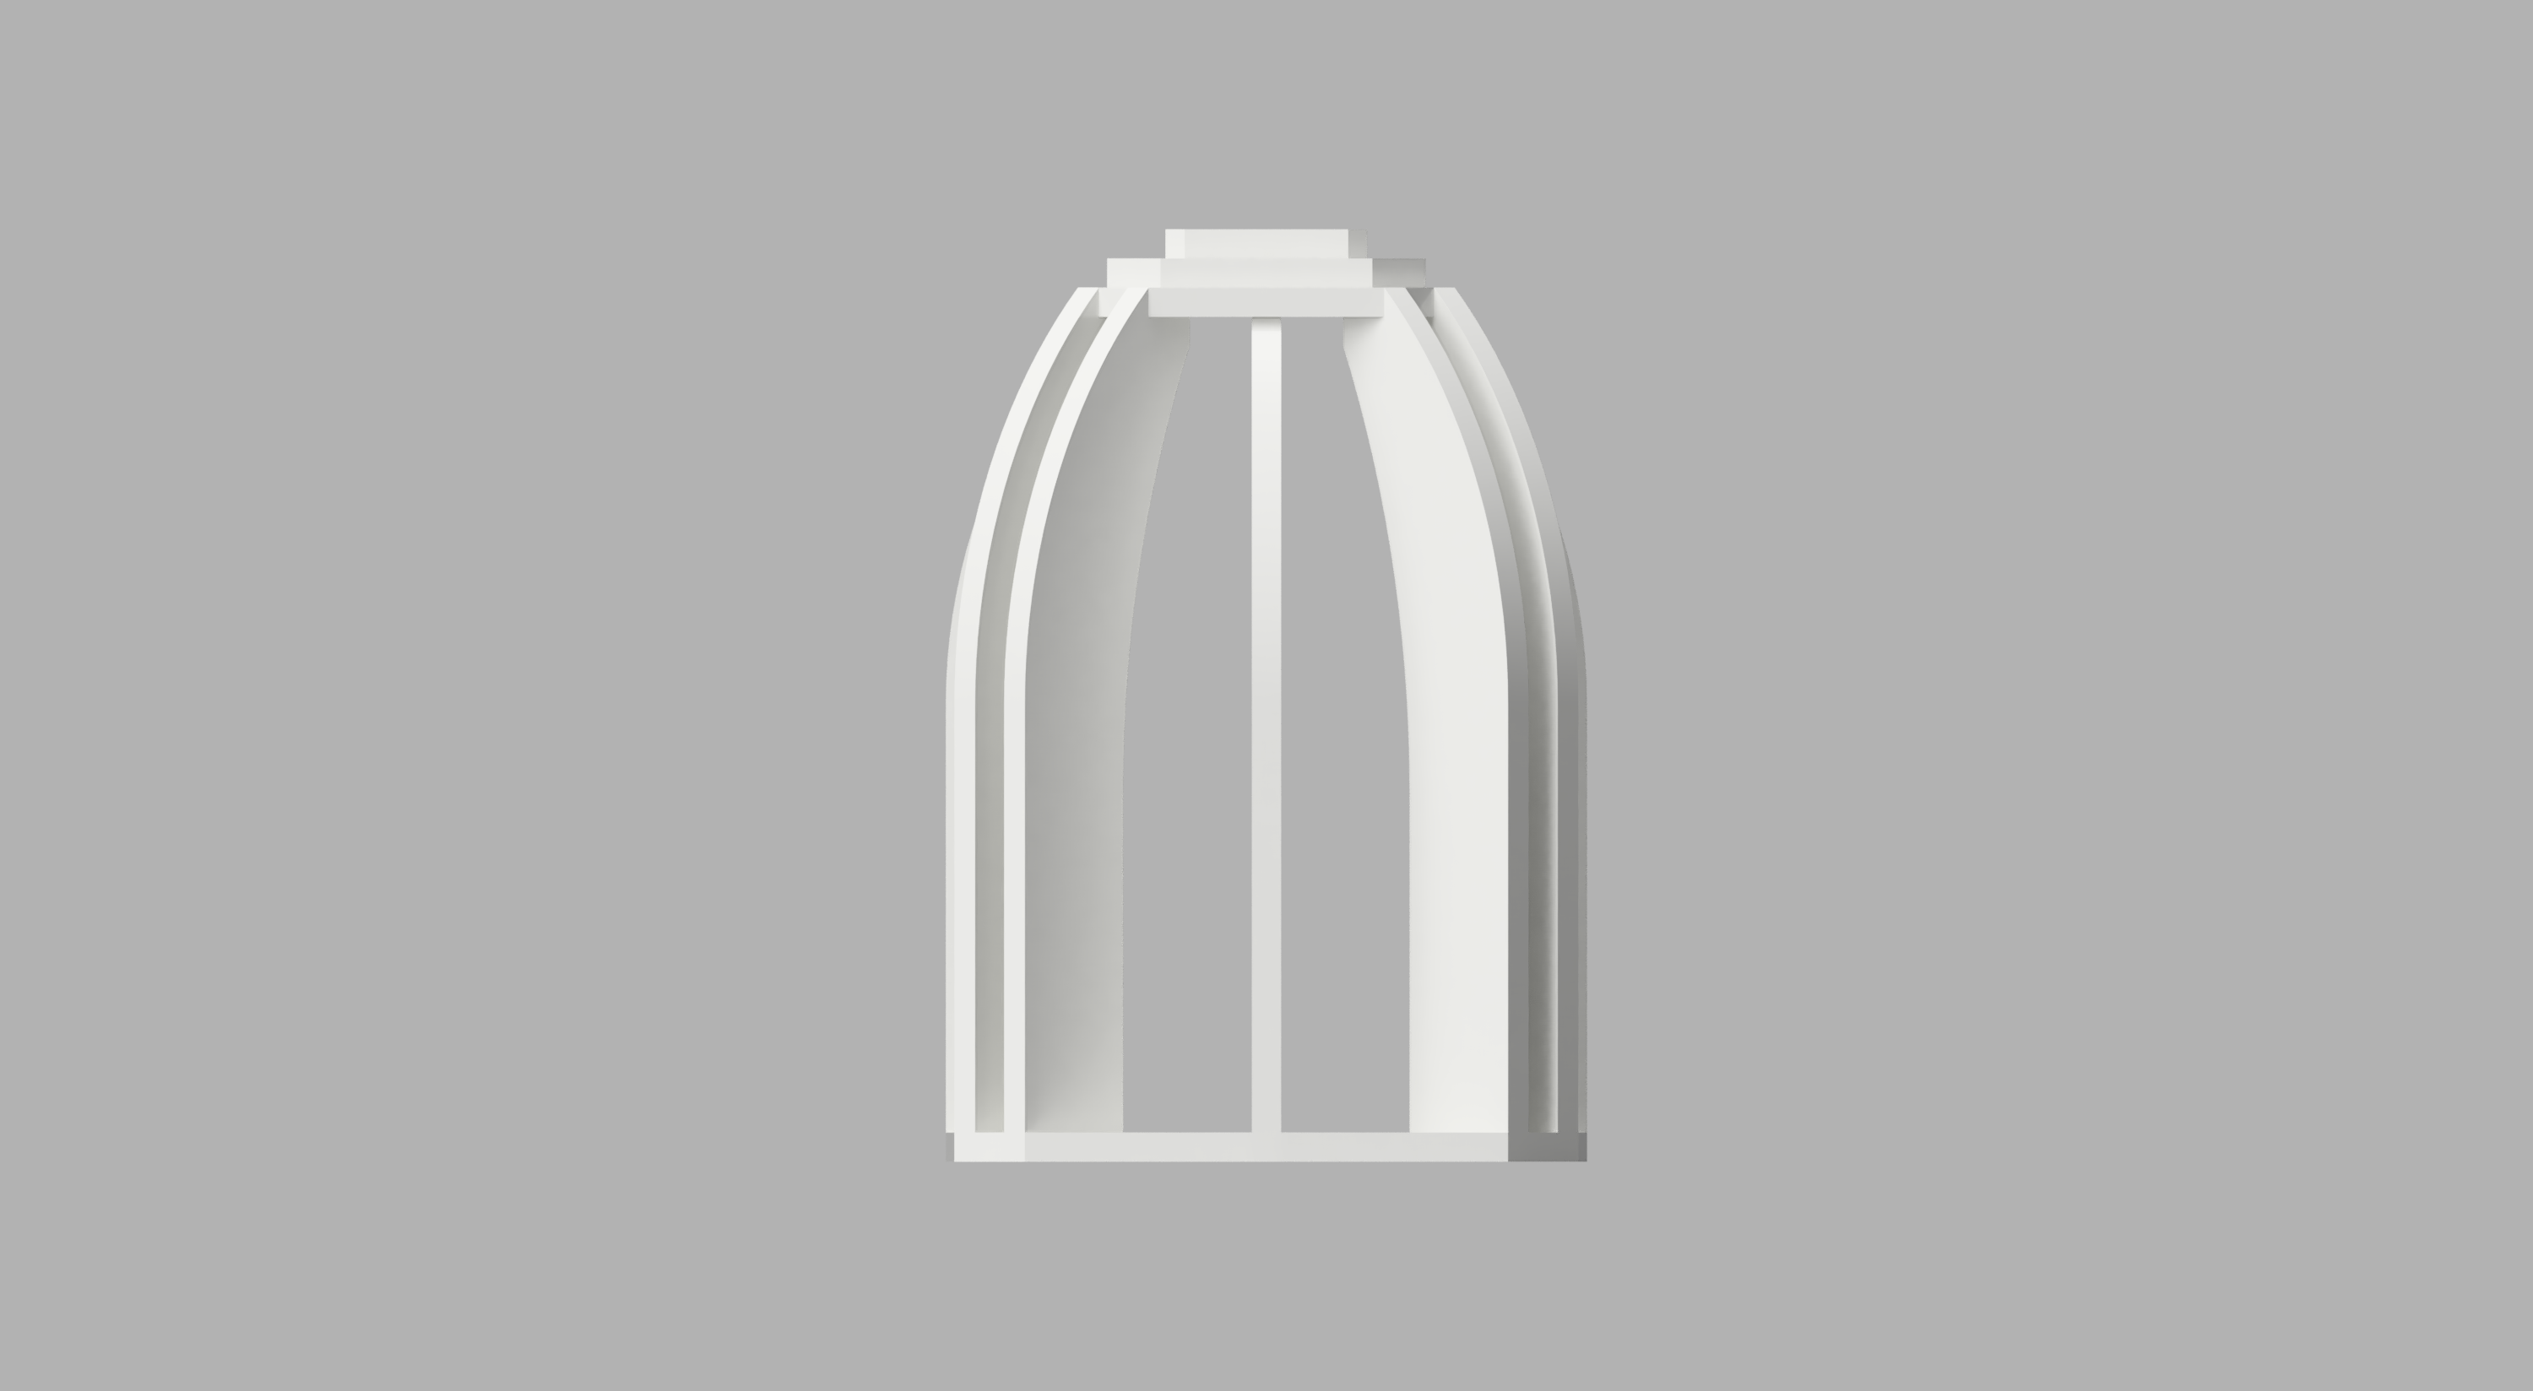

* + - Bottom

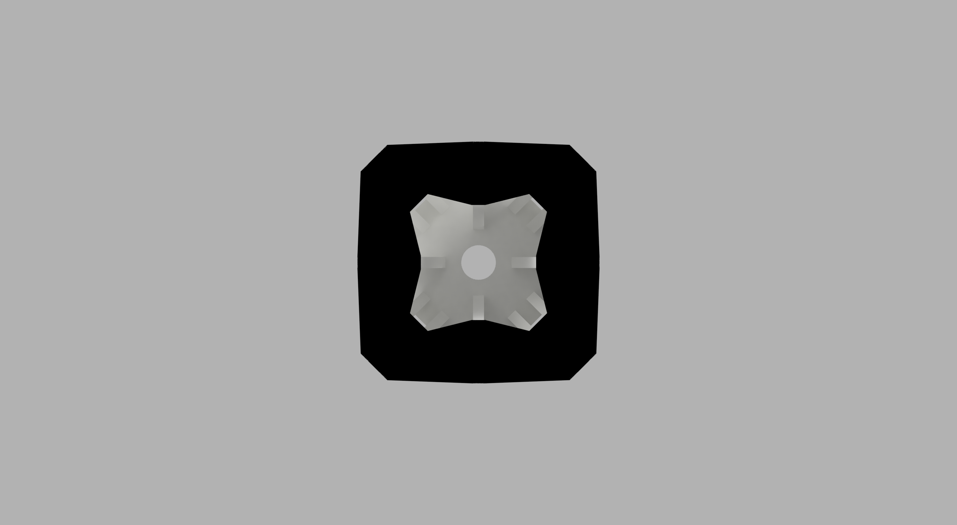

* + - Exploded and flat-pack views

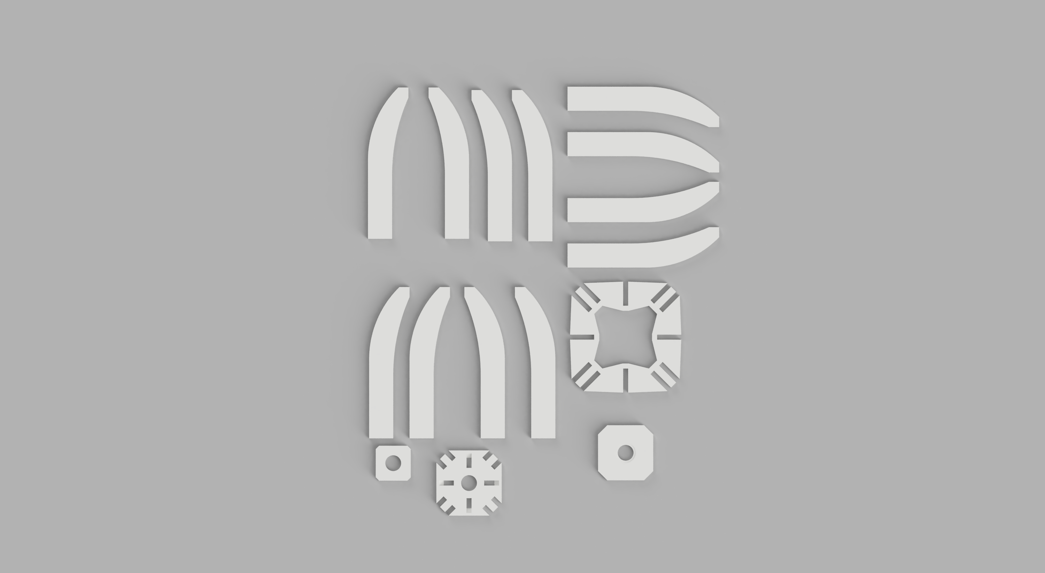

* + Fabricated from a 48 x 48 x 0.5” MDF panel
  + Uses a HEMMA set: <http://www.ikea.com/us/en/catalog/products/10175810/>
  + Surface finished (sealed or painted) and assembled

